<https://www.youtube.com/watch?v=_-CD_5YhJTA>

* Leading framework for developing JS applications
* SPAs applications
* Type Script – Superset of JS

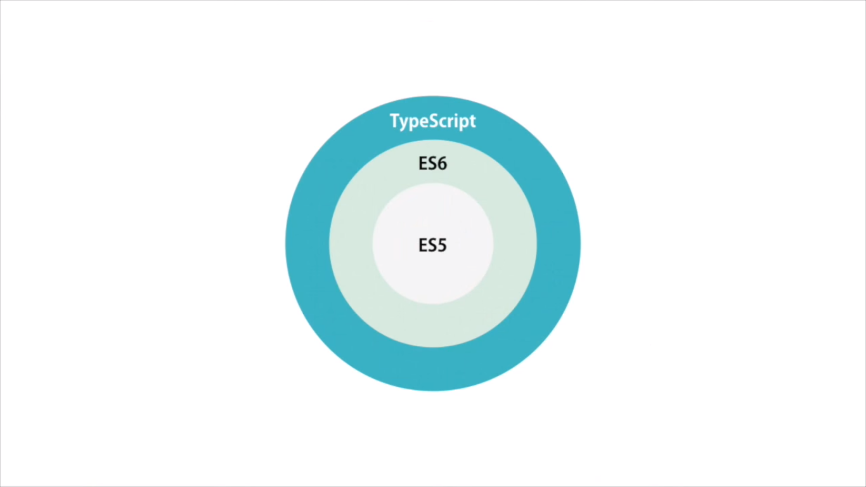

* Key Players in Angular App

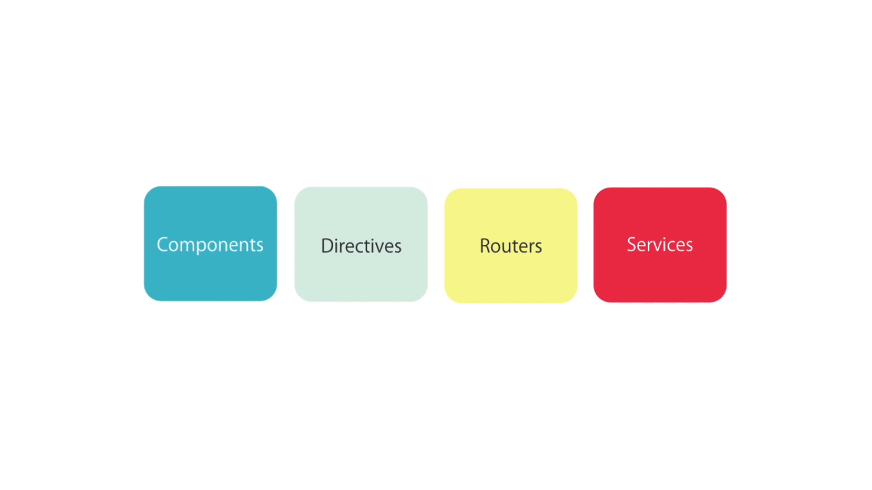

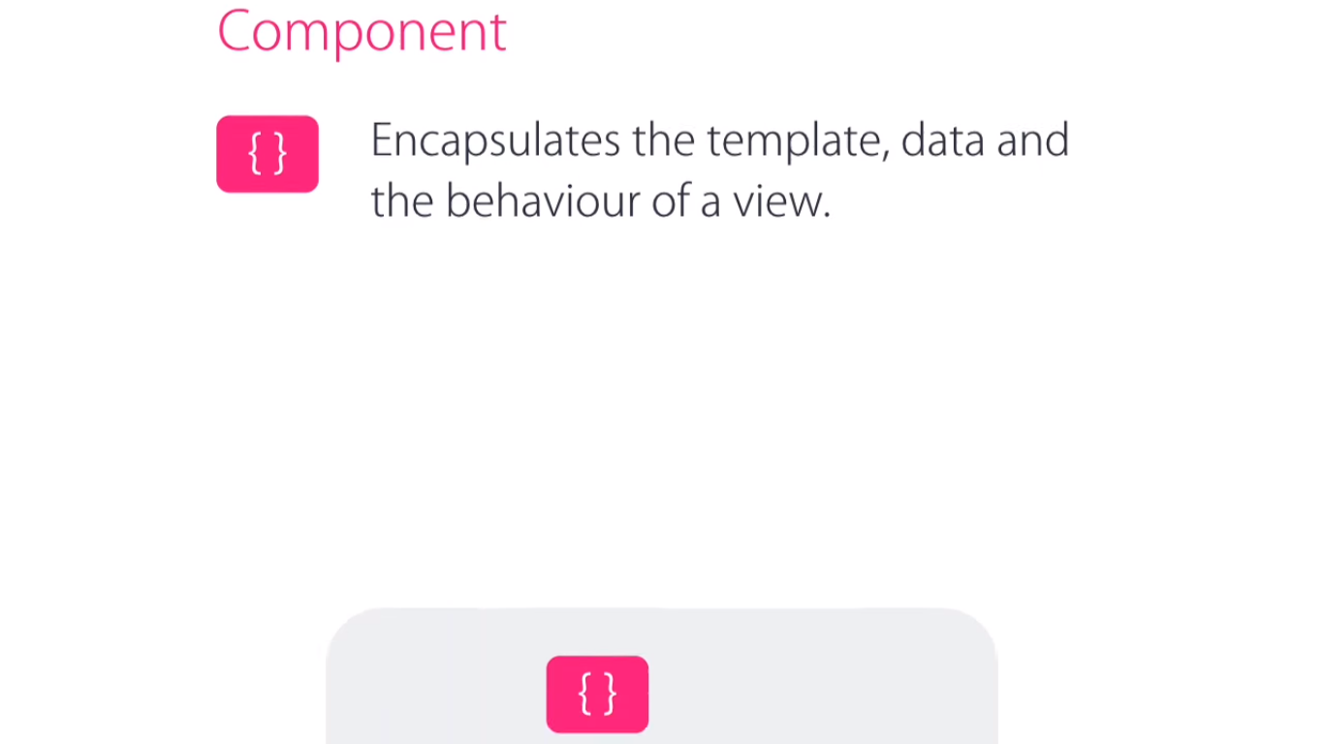

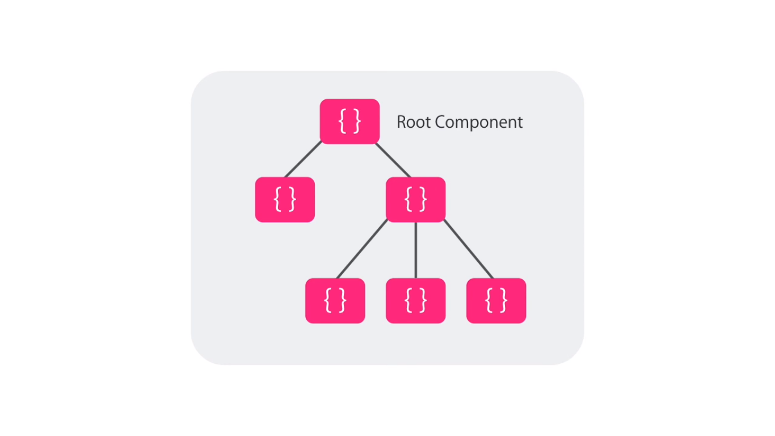

* E.g.: To build an app like Udemy, we can have three components:

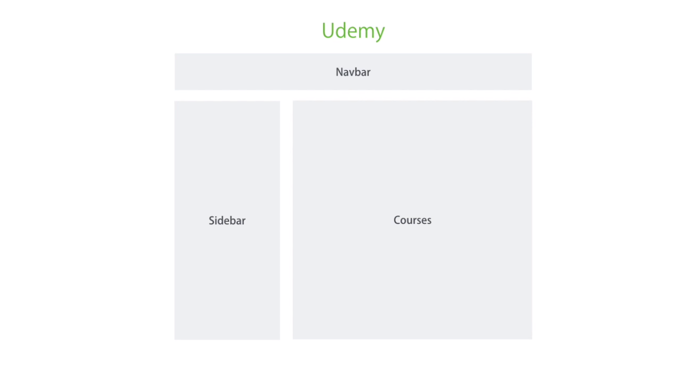

* Each of the component can contain further sub components:

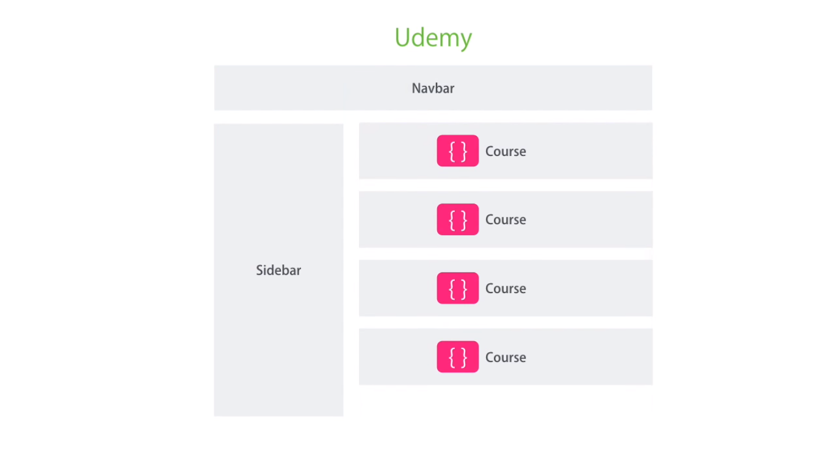

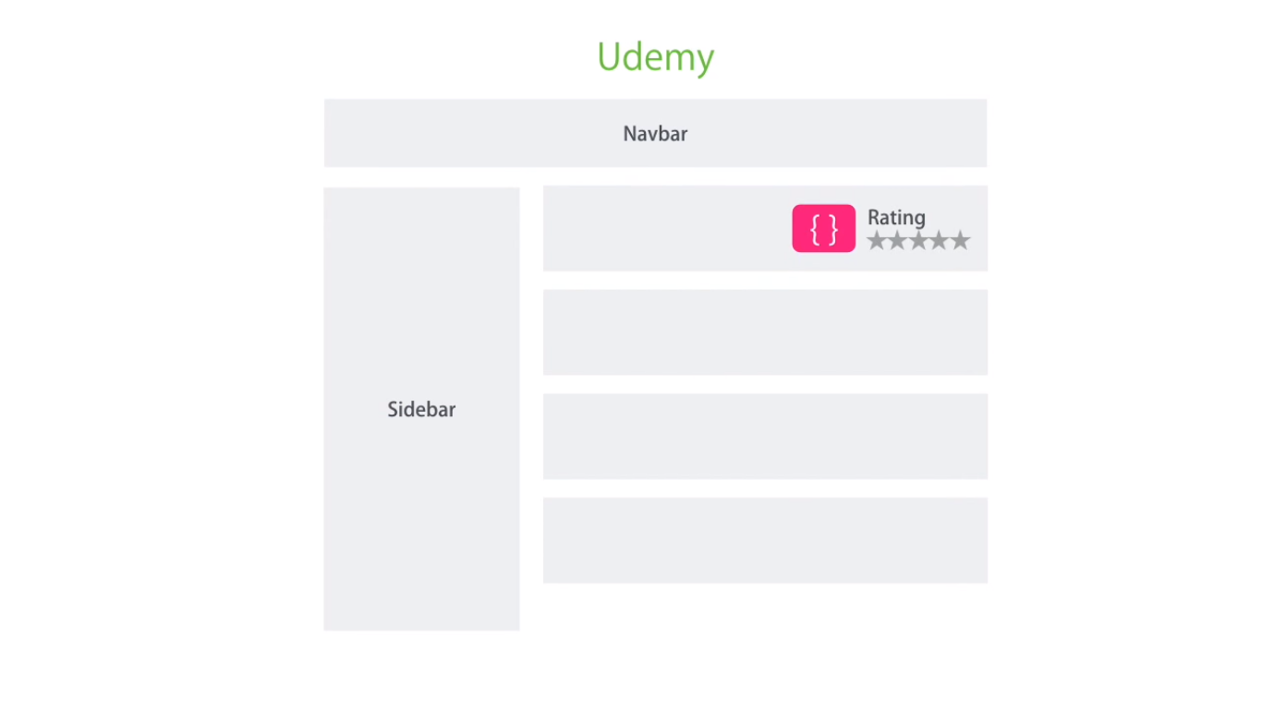

* This allows for a better structured applications and helps in breaking a large complex application into smaller and more manageable components: called view components

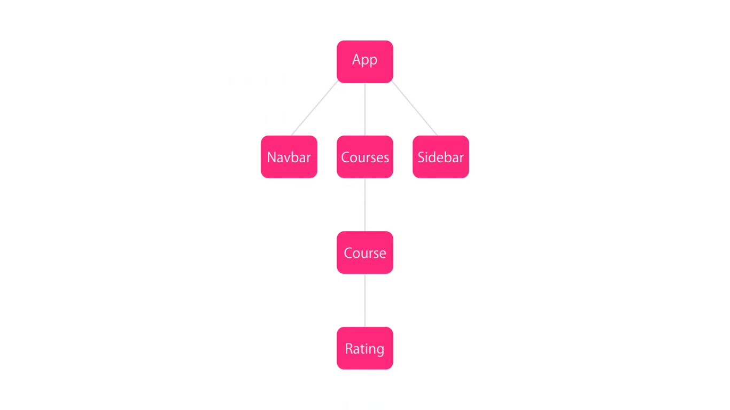

* What’s a component in NG2? Its simply a typescript class

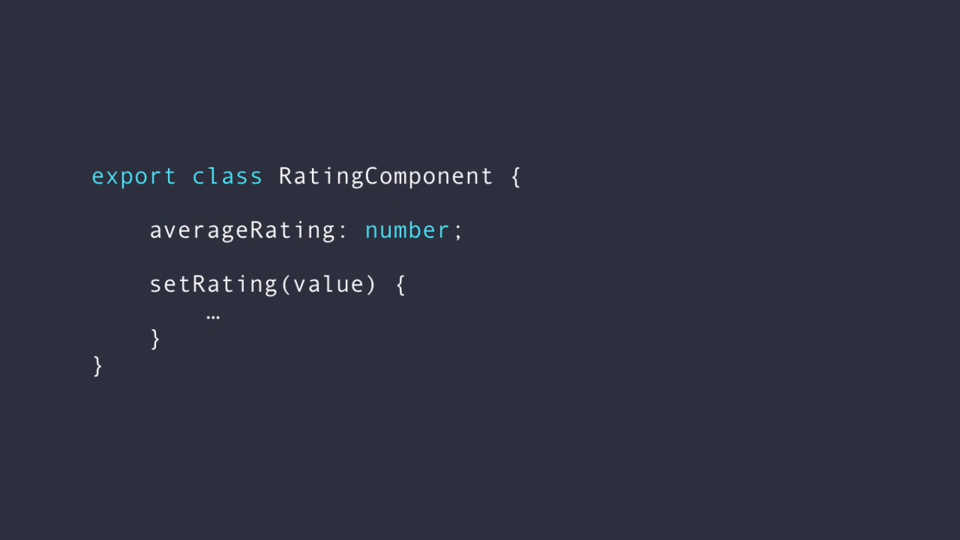

* In angular, components are completely decoupled from DOM

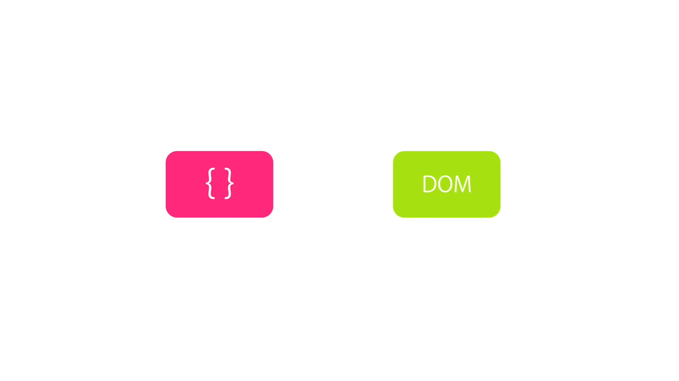

* In application written in something like javascript or jquery, we get handle of DOM element to modify or handle events

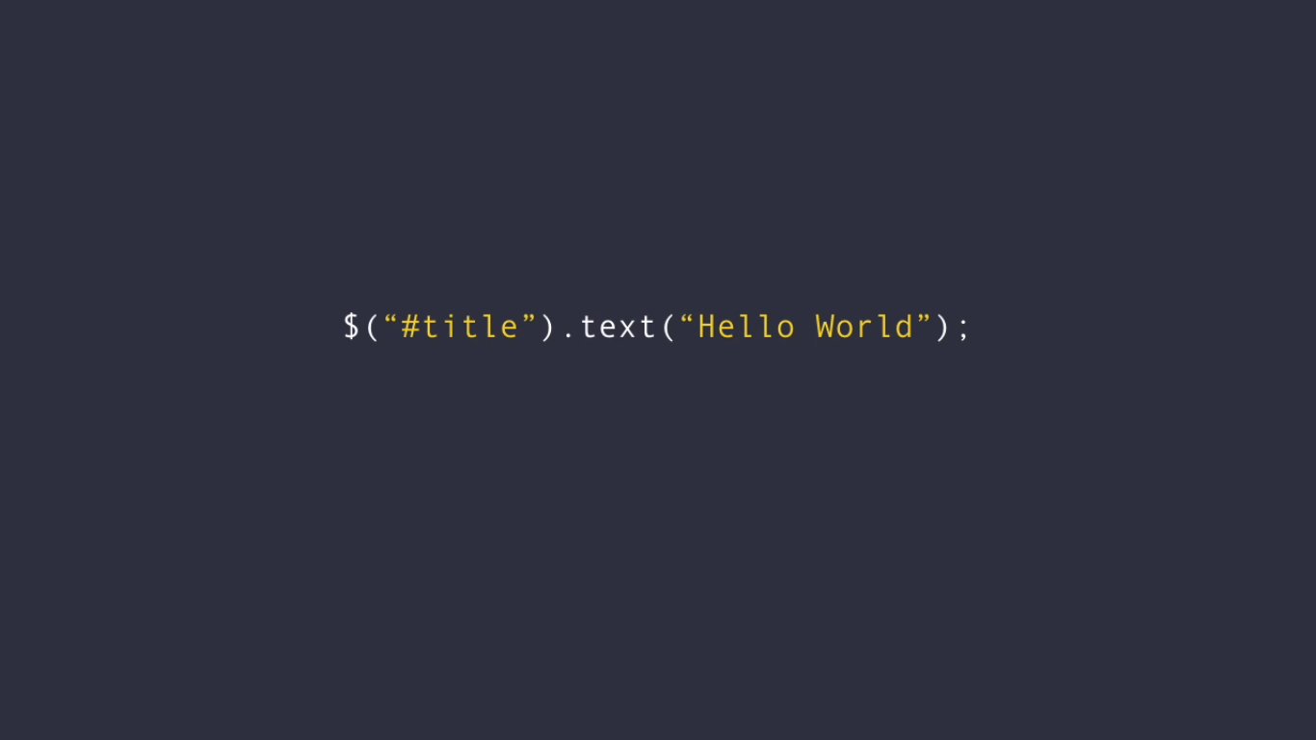

* However, in angular, we use binding where in the view, component and its properties are bound to DOM element. So if there is a change in the bound property, DOM element associated automatically reflects that.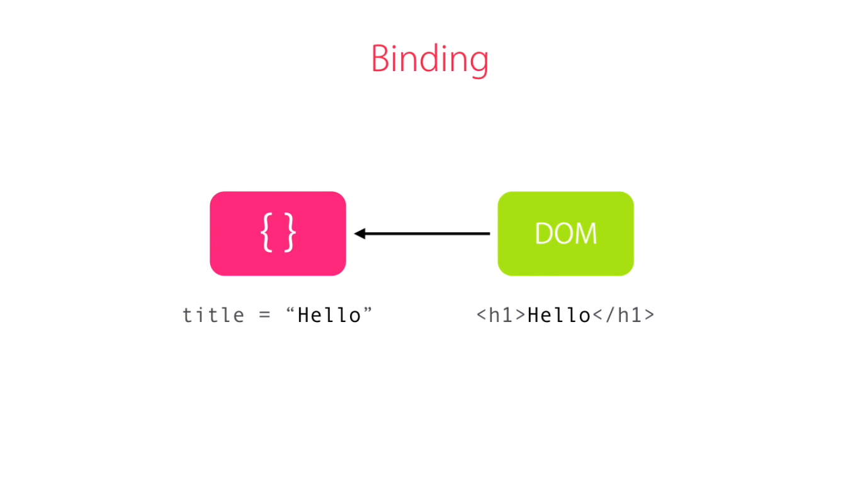
* Similarly to handle an event raised from the DOM, we bind the event to a method in the component.

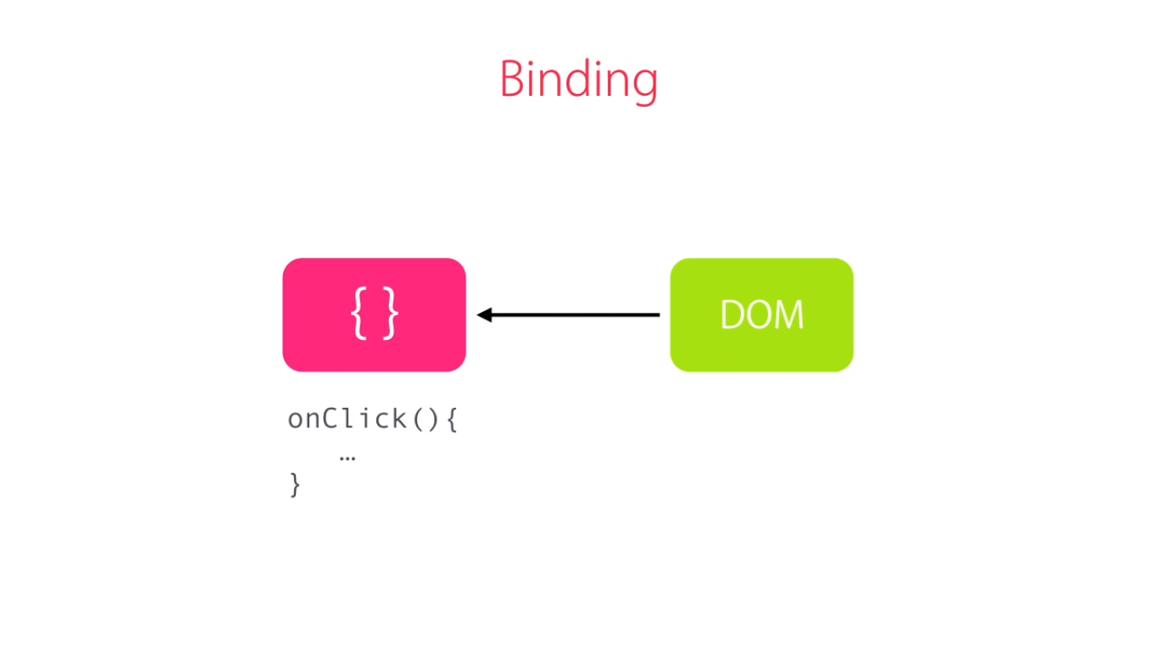

* This decoupling allows for unit-testing of the components (classes) without even having a DOM
* In a typical application, interaction with backend application etc is needed to access database, logging etc. This is a task that is handled by service that sit between the components and the backend.

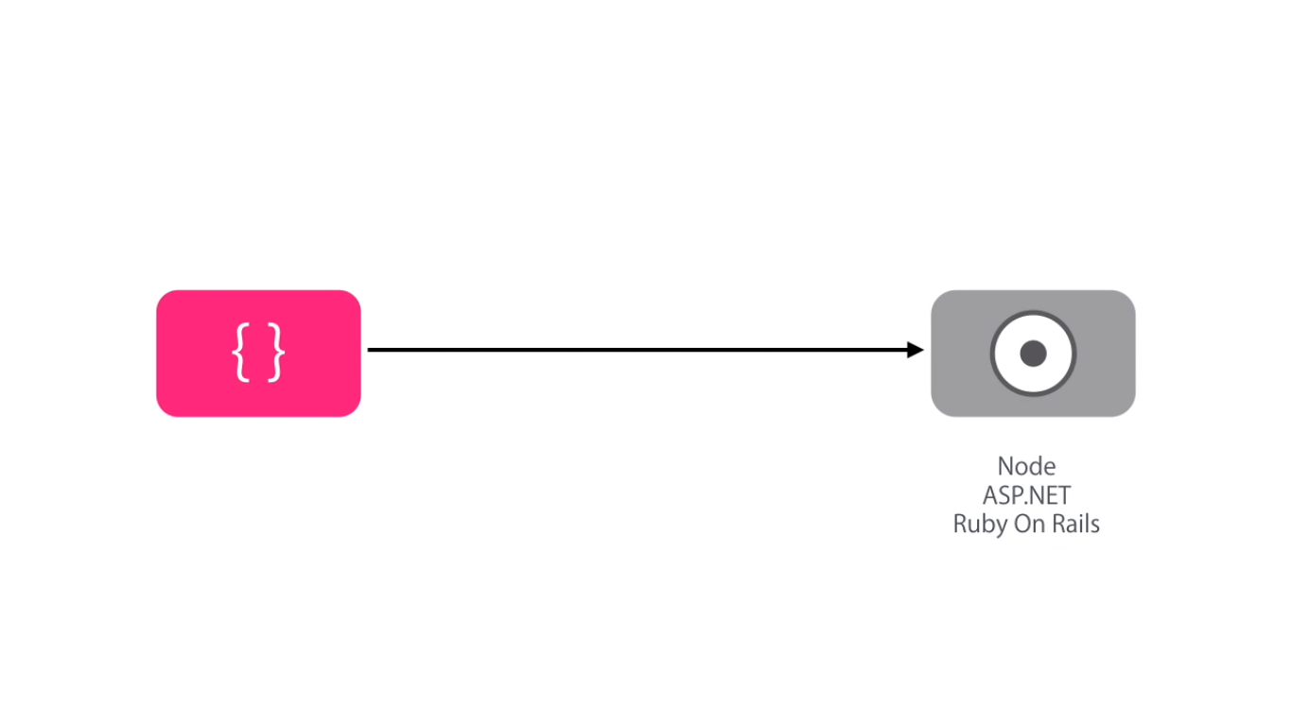

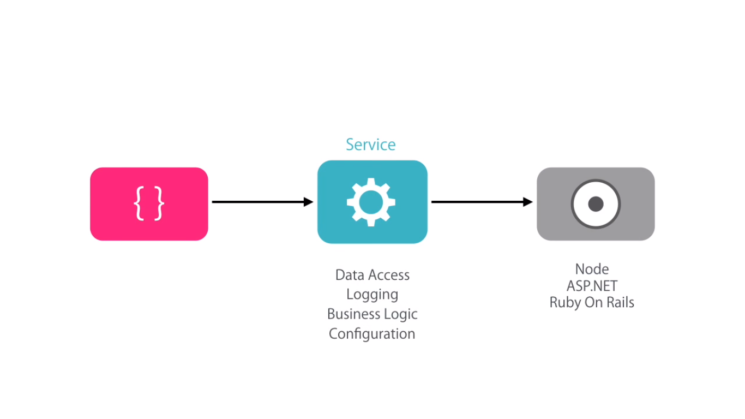

* Router is responsible for navigation:

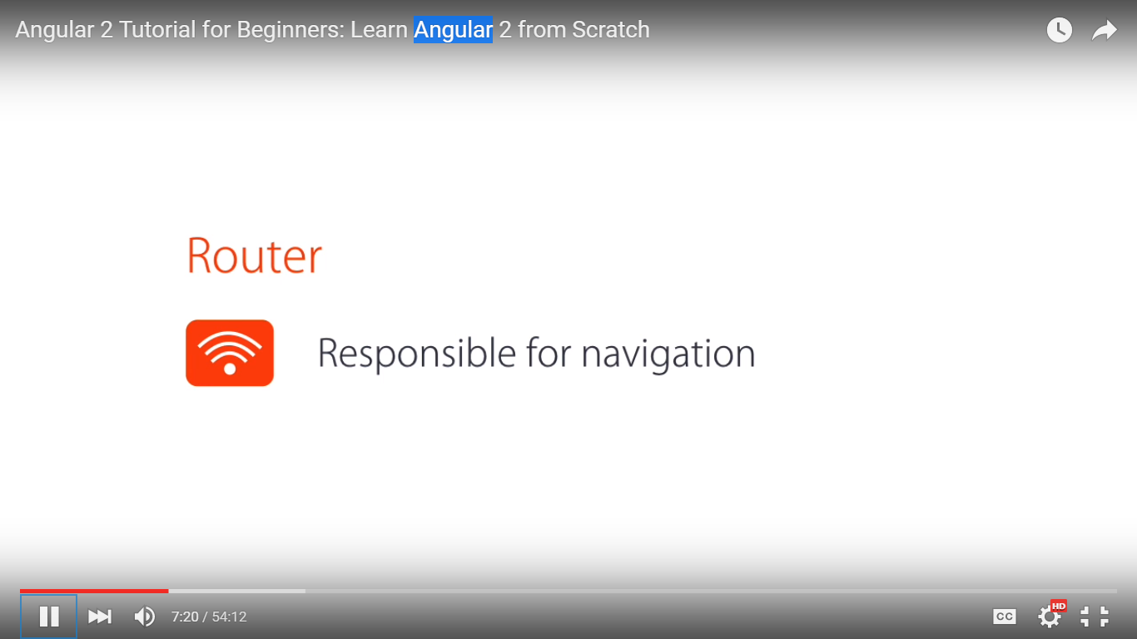

* Last key player: Directive:

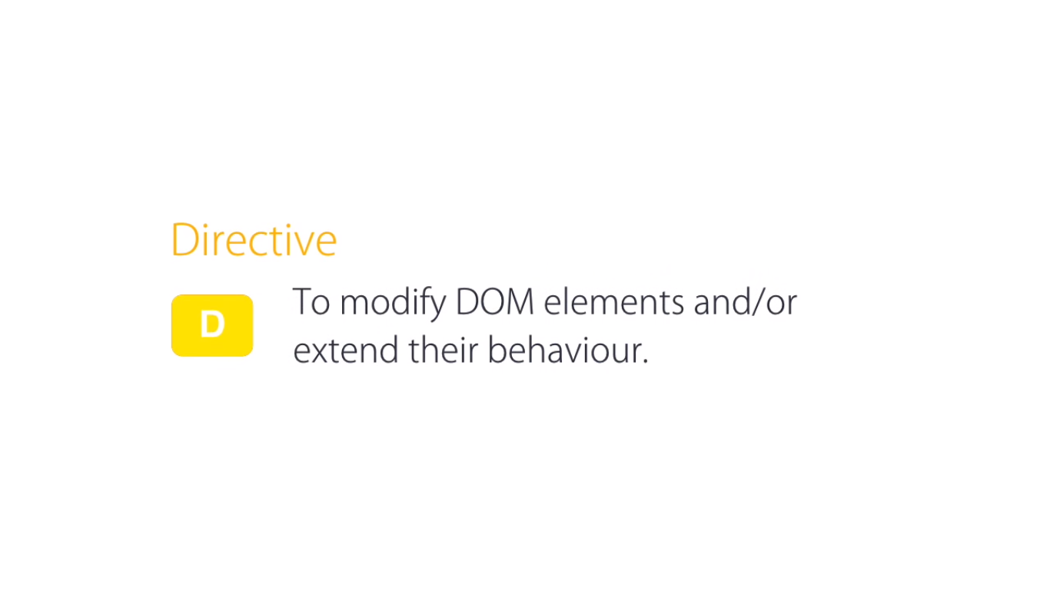

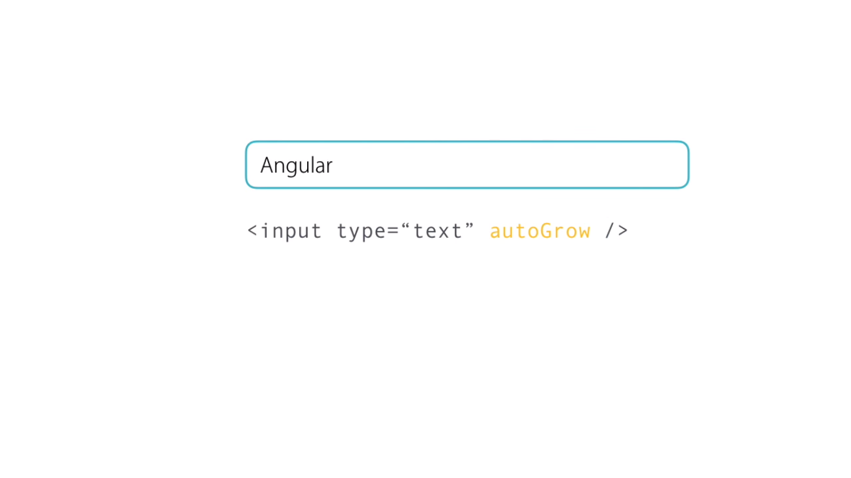

Adding classes, styles as well as creating our own directives

**Setup the Dev environment:**

1. Setup Node: Download and setup
2. Install typescript: npm install typescript
3. Proper way to setup an ng project will be through cli:
   1. npm install –g angular-cli
   2. ng new project_name
   3. ng serve
4. However as that’s not available, download the seed project from <http://bit.ly/1X0El6t> and unzip.
5. Structure of the seed:
   1. Tsconfig.json 🡪 Typescript compiler config file to determin compile or transpile ts files to js (current version ES5)
   2. Typings.json 🡪 typescript definition files
   3. Package.json 🡪 Node config. IT contains some custom node commands, dependencies etc.
6. Once unzipped, install it: npm install
7. All the dependencies are stored in **node_modules. They are downloaded from npm-repository**
8. **Under scripts section: commands that can be run: Start 🡪 performs 2 node commands – compile and start**
9. **Go to Localhost:3000**

* Compilation generates a app.component.js javascript file and javascript mapfile that is use for debugging.

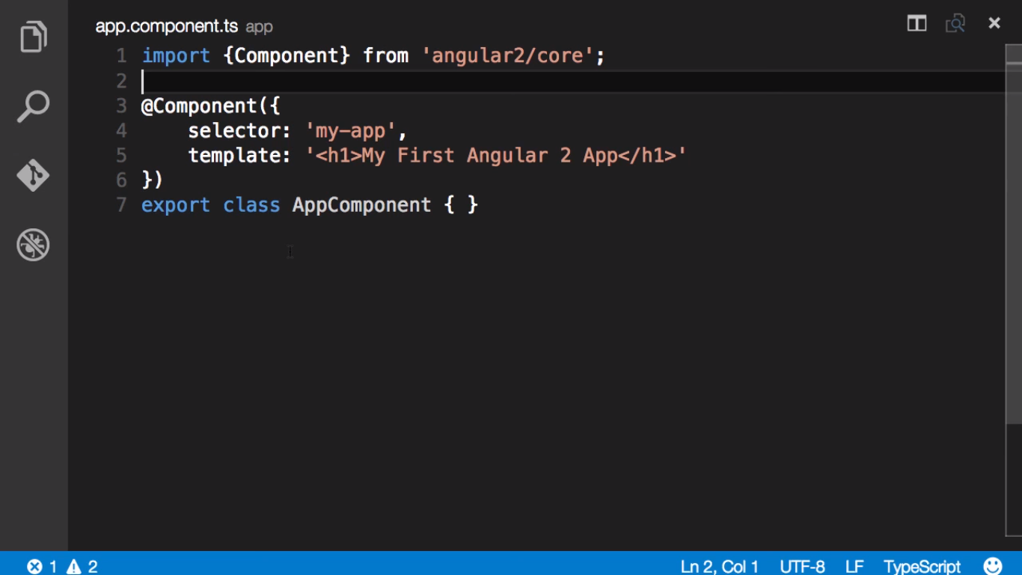

Root component is a plain typescript class. Its decorated with component decorator (annotation) that adds metadata about class.

So all angular 2 apps are plain TypeScrpt classes that are decorated with some decorator.

Once we make a change to the decorator (say the template), and save, this is automatically reflected in browser without doing an F5. BrowserSync takes care of doing it. This is happening in the watch mode in the light webserver

* BrowserSync:
* Transpiler
* Light Browser in Watch mode

For a build automation tool like Gulp or Grunt, typescript compilation will be another step.

Creating a Component:

* Create a new file: course.component.ts
* Create a class in it and decorate with annotation to indicate that this is a component:

import {component } from ‘angular2/core’

@component ({

})

export class CoursesComponent {

}

* Export indicates that the component or class will be available for import in other components for usage.
* Decorators are functions and hence have to be called along with @ annotation passing in the object. Two of the basic attributes
  + Selector(courses): specifies a css selector for host html element. When angular sees matching, it creates instance of this component in the host element. Host element in this example is “courses”
  + Template: Can be put inline or separately in a file. This specifies the html that will be inserted into dom when component view is rendered.

Directive: Extends the default behavior of html

Exercise:

1. Create Courses component
2. Open app.component
   1. Add courses html element
   2. Add import: import {CoursesComponent} from './courses.component'
   3. Add directive : directives:[CoursesComponent]
3. Create Service

**Dependency Injection: inject dependencies of classes when creating them.**

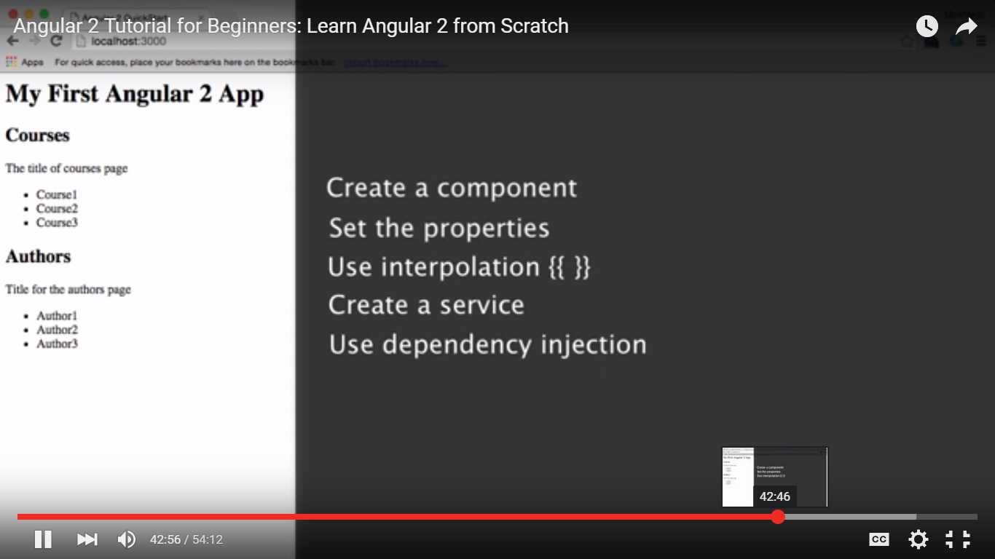

**Interpolation {{}} is used to set the properties of the component class into the view**

**For dependency injection we use providers**

**Directive:**

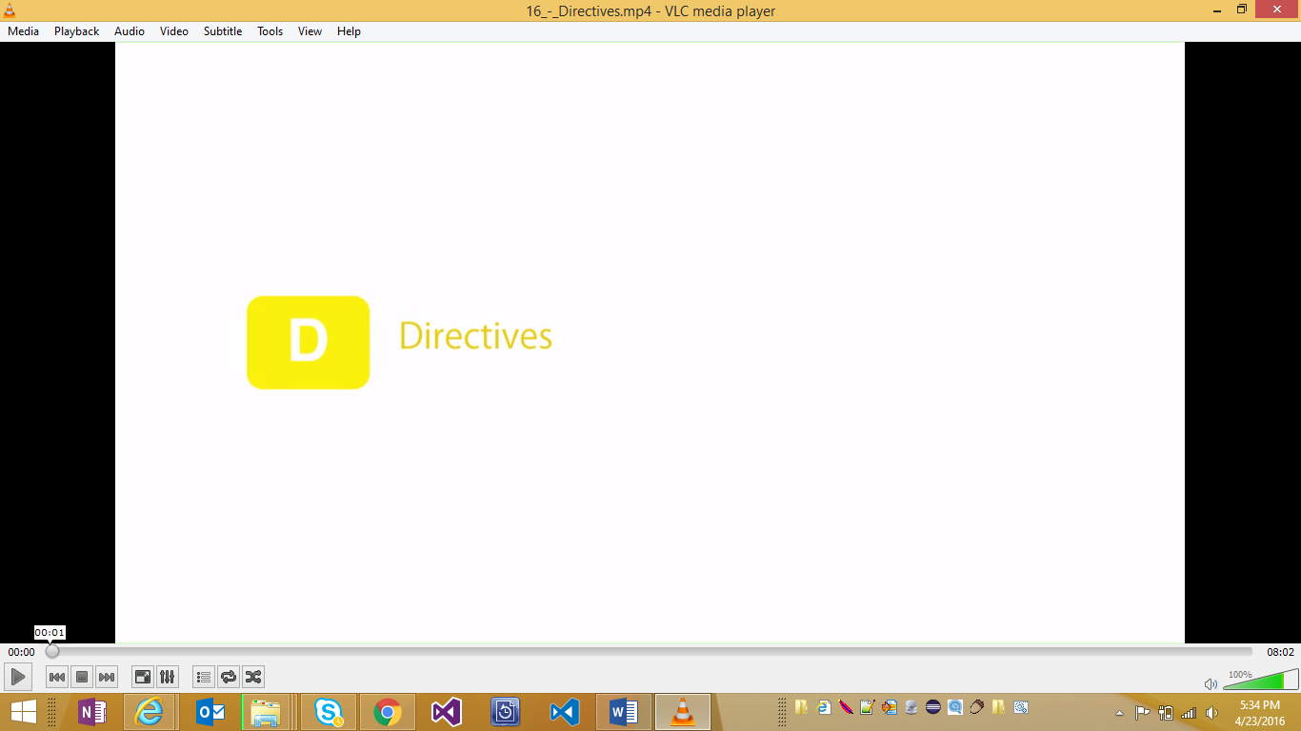

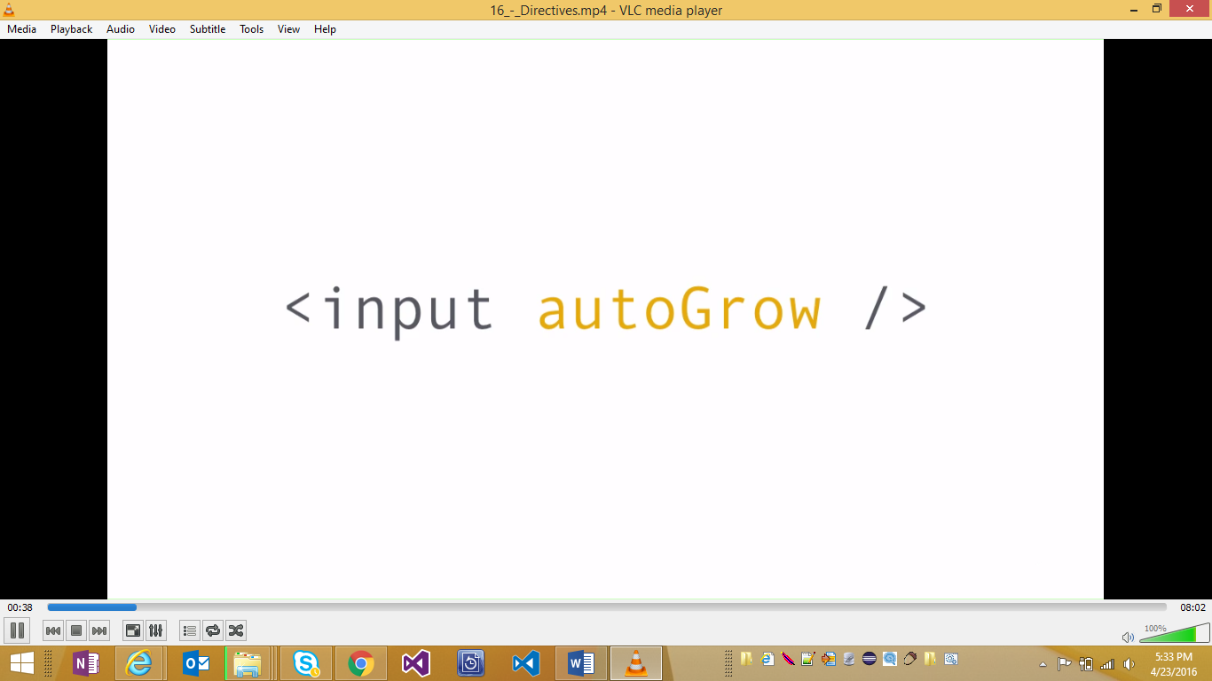

**Steps:**

1. **Create a new directives file**
2. **Import directives**
3. **Create class**
4. **Decorate with selector (name of directive) and hosts (fuctions/events )**
5. **Import ElementRef (access to host element) and Renderer (service used to modify host element)**
6. **The renderer and host element ref have to be added as private attributes to the directive class. There are two ways:**
   1. **Traditional: add private variable (starting with _ e.g. _elementRef) and set to value in constructor**
   2. **Cleaner way: use private keyword in constructor**
7. **Now add code to the functions (blur and focus). To access the dom element, use this.el.nativeElement**
8. **In the onblur and on focus, set the element style of the renderer**
9. **In component Metadata, directives is used to set the custom directive.**

**Types of Binding:**

1. **Property and EventBinding**
2. **Class Binding**
3. **Style Binding**
4. **Two-way binding**

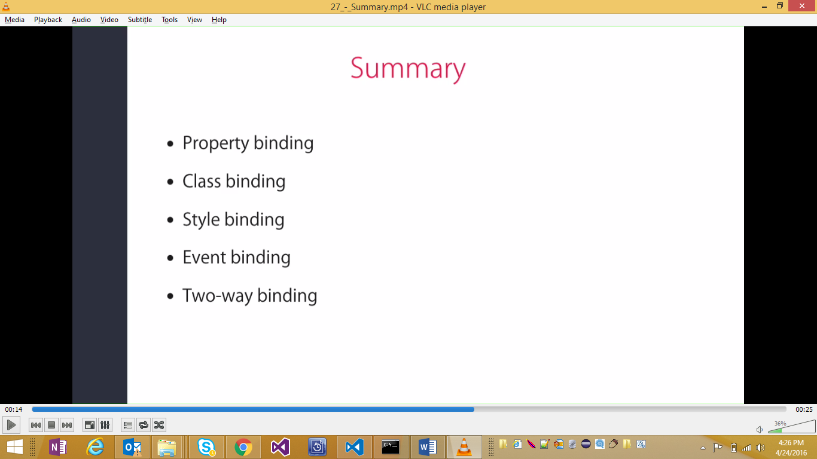

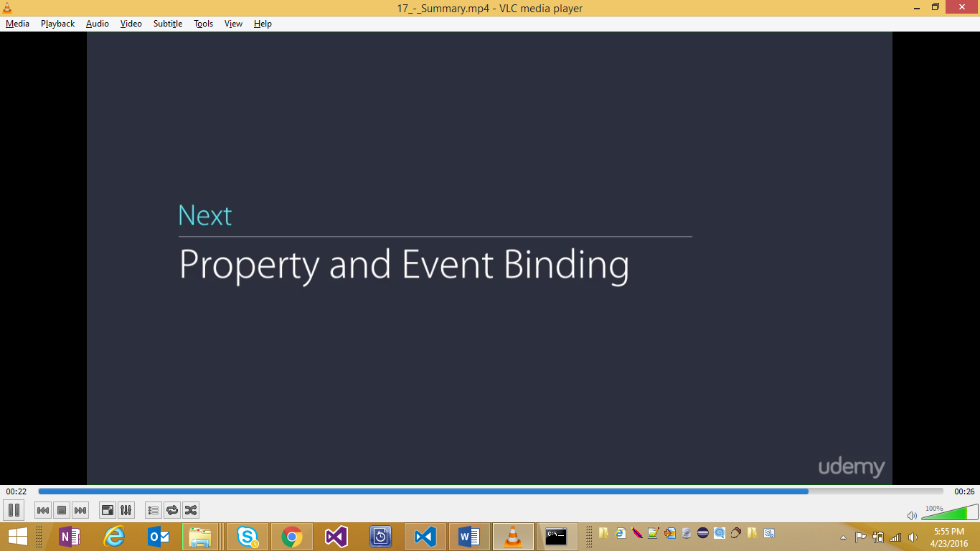

* **Interpolation {{}} is used for property binding behind the scenes when angular processes it.**
* **Property of a dom element is bound to property of a component**
* **There are three ways of doing it:**
  + **<img src={{image_url}} /> 🡪 This is inter polation**
  + **<img [src]=image_url/> 🡪 This is binding style 1**
  + **<img bind-src=image_url/>🡪 This is binding style 2**

**Any of the three can be used but 1st one is cleanest. Technically all three are same as even the first one (the interpolation) is converted to binding behind the scenes**

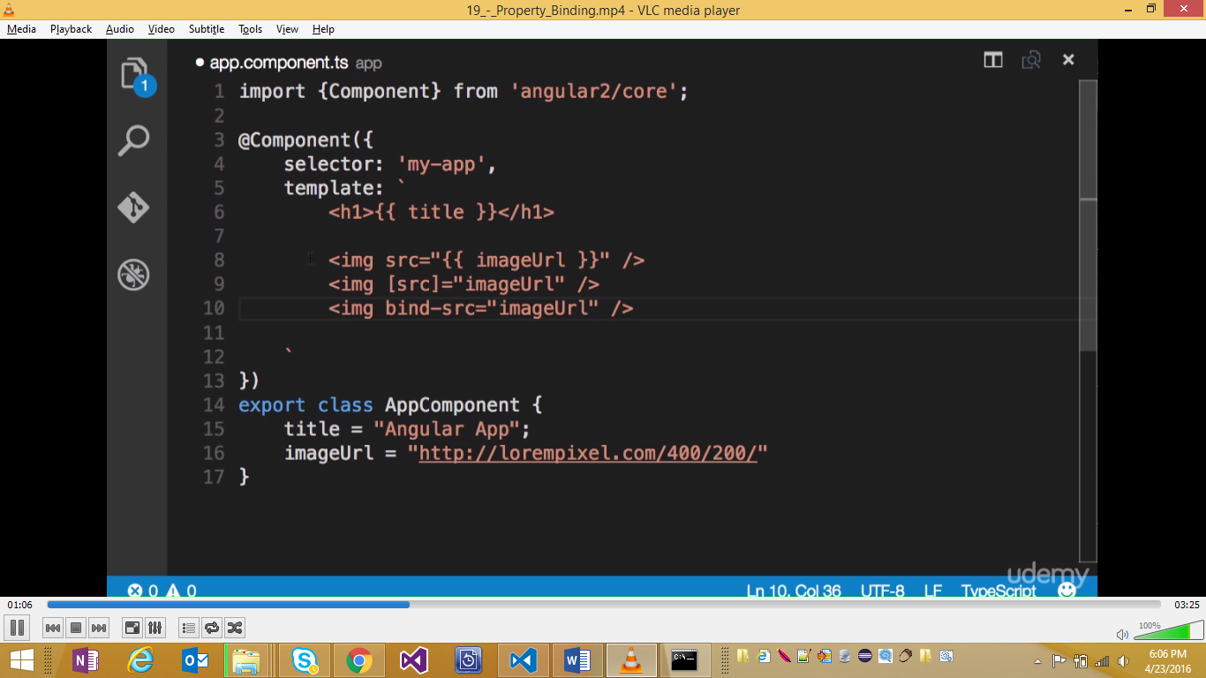

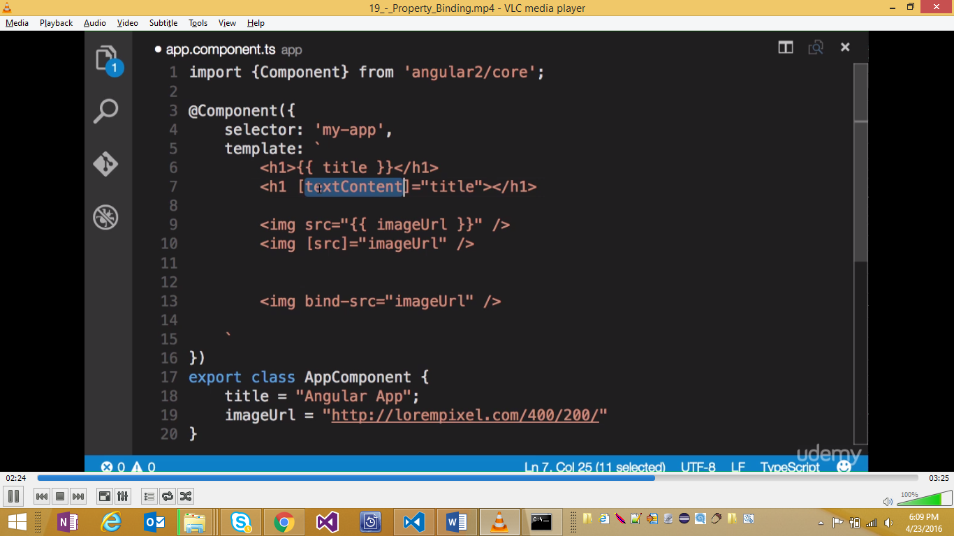

**Note: the html elements in the template are not really html tags rather they are dom elements and hence may have attributes like textContent.**

* **This binding is one way i.e. it binds components to dom elements**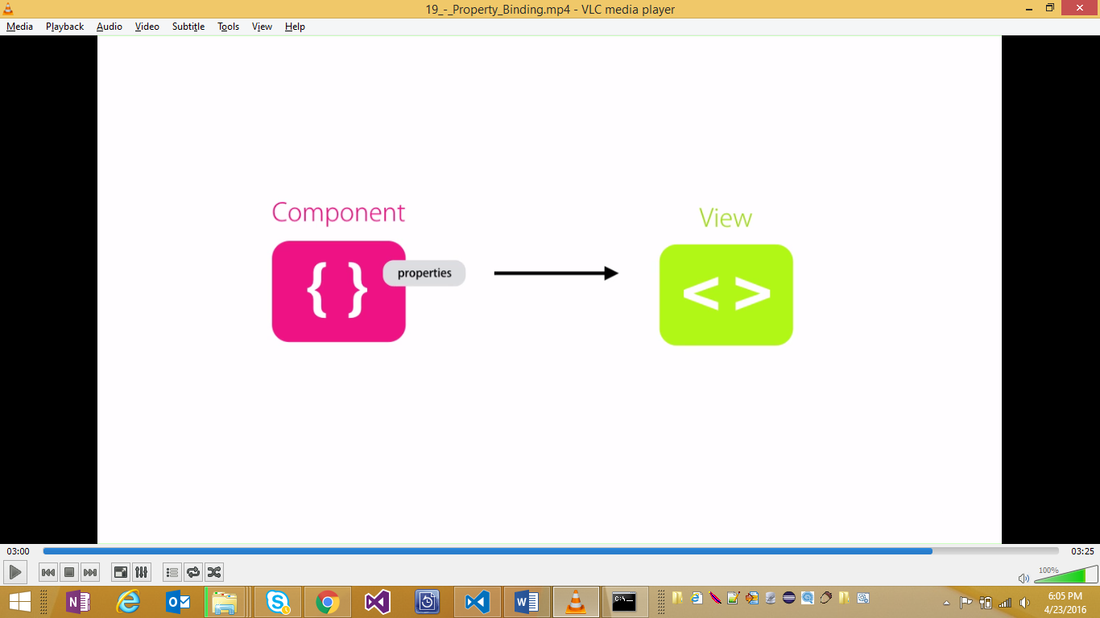
* **So any changes in dom are not reflected in the component. For that 2 way binding has to be used.**

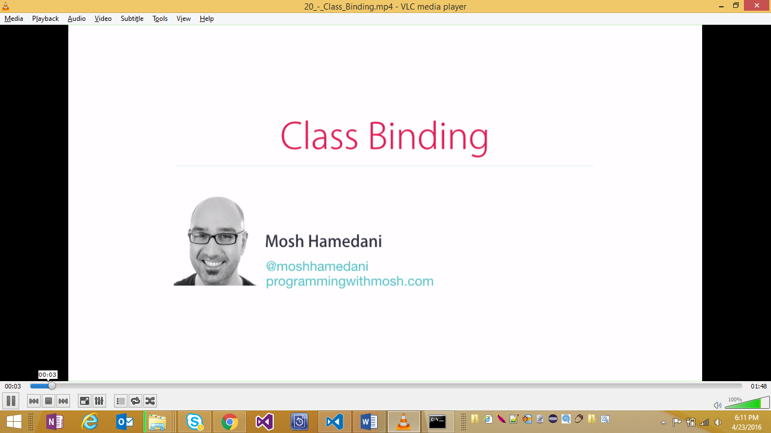

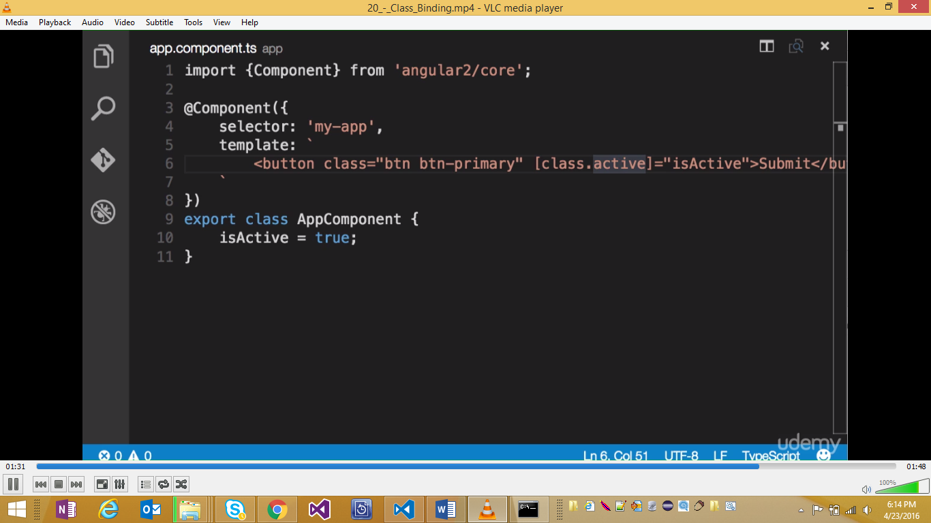

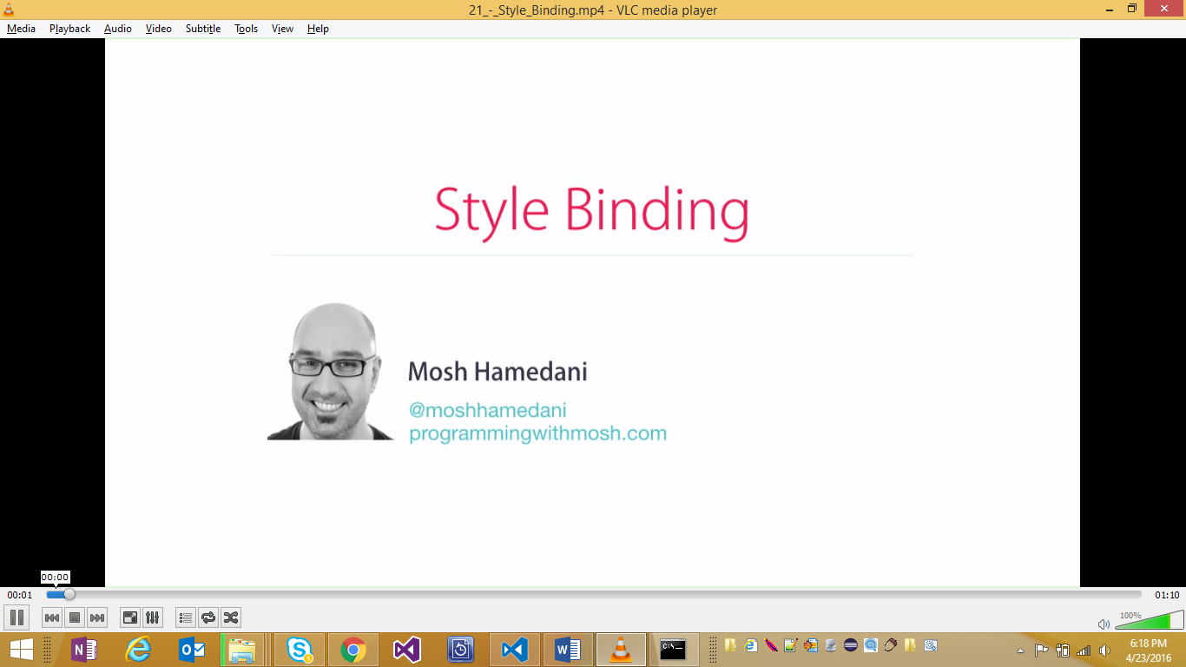

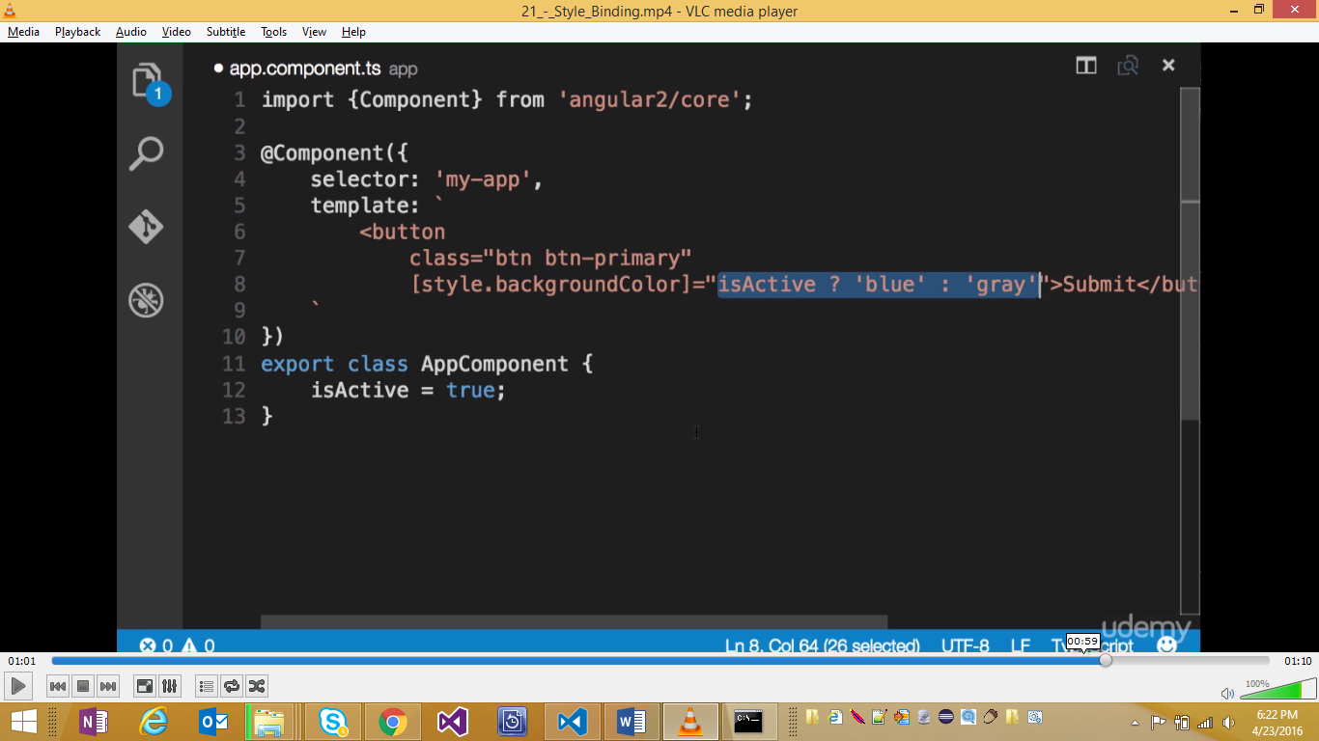

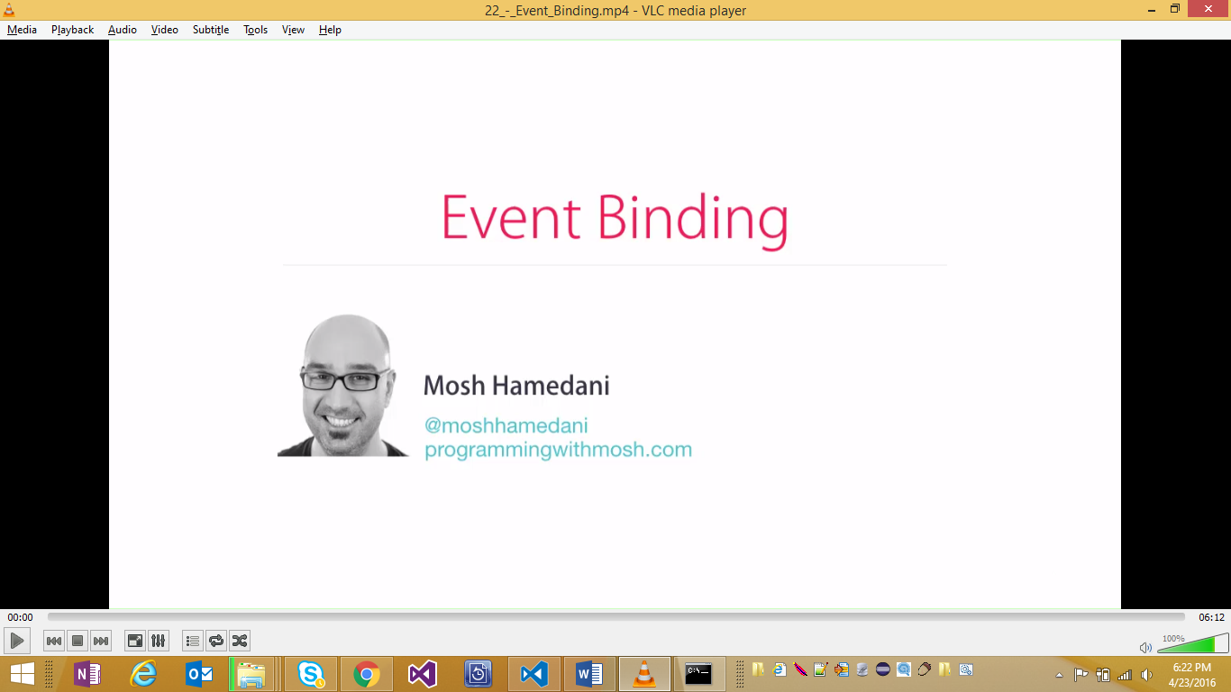

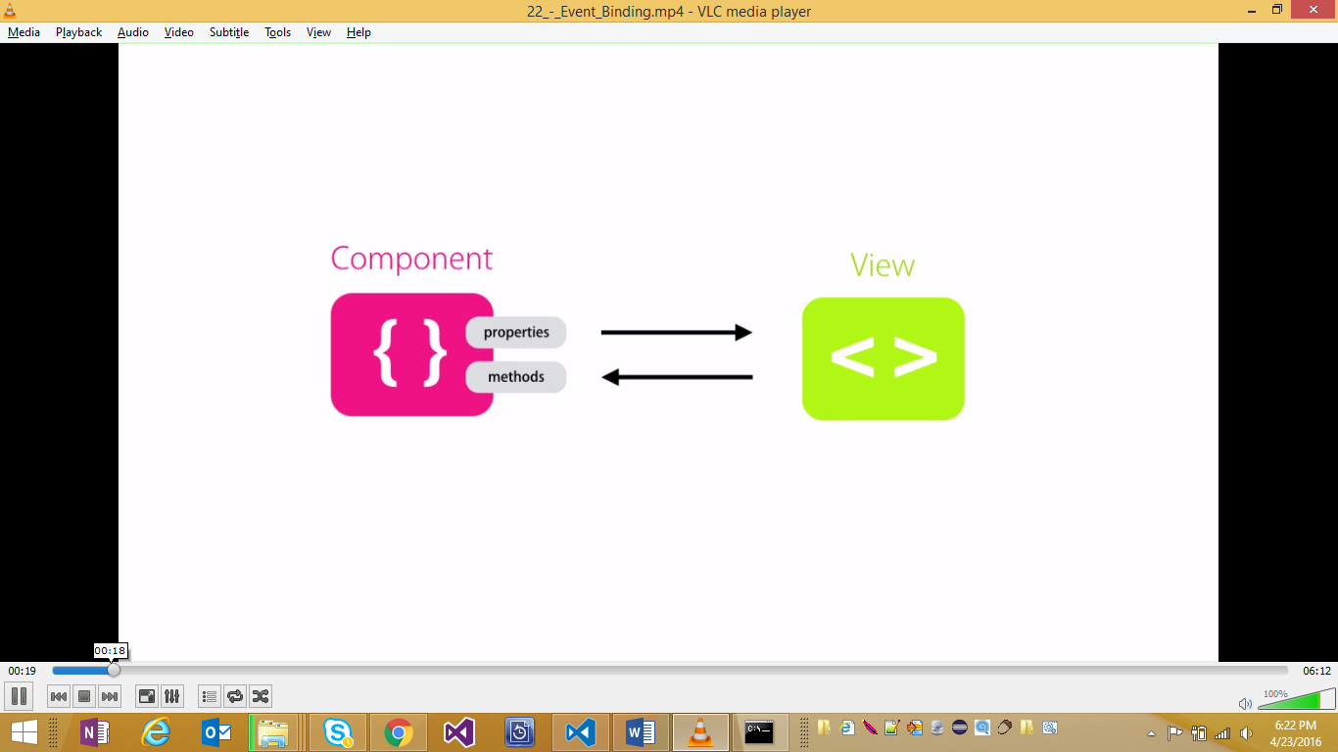

**To handle events raised from dom (e.g. mouse click etc)**

**There are two ways: () or prefix**

**Binding expression is often a method in the component**

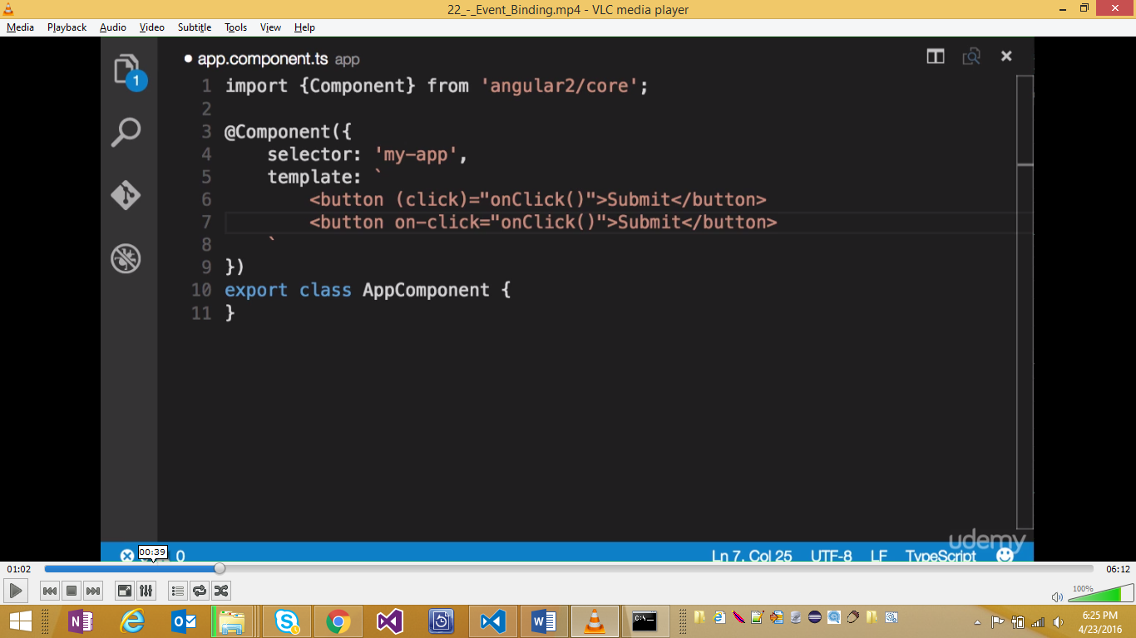

**Both the options are same. It’s a matter of personal choice**

**Rule of thumb” Property use []**

**Function.event ()**

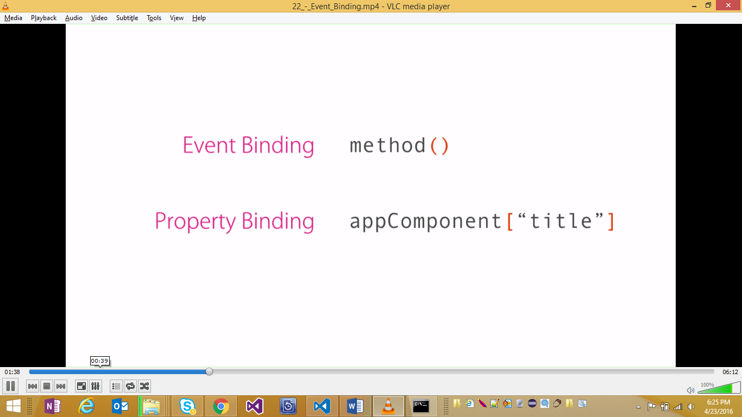

**\*\* IF need to pass the event, $event that will have all the properties associated with the event**

**Its prefixed to$ as its builtin to angular**

**Instead of dom events, custom events may also be raised**

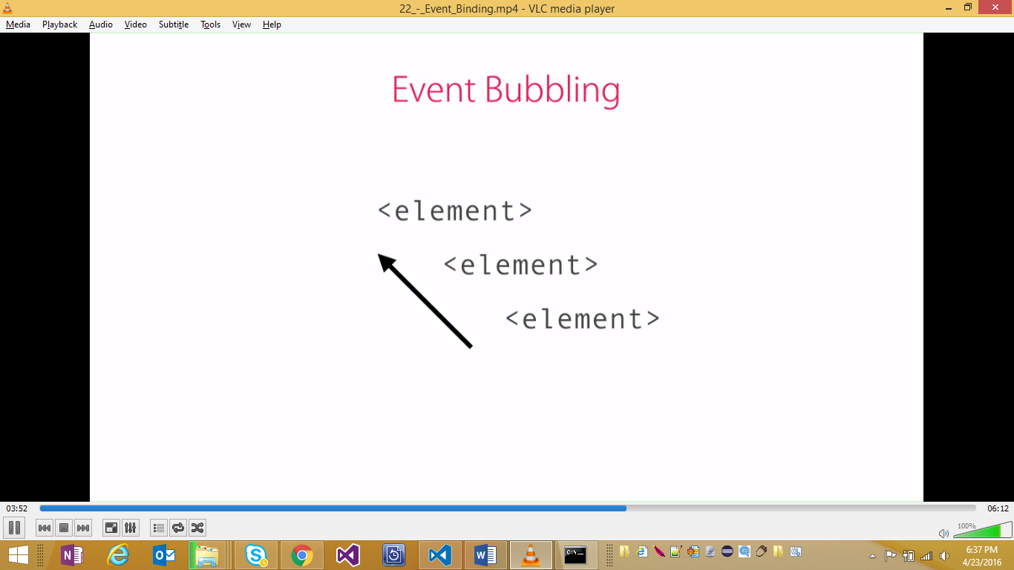

**Dom events bubble up. Standard featyre**

**To stop bubbling, use event.stopPopagation**

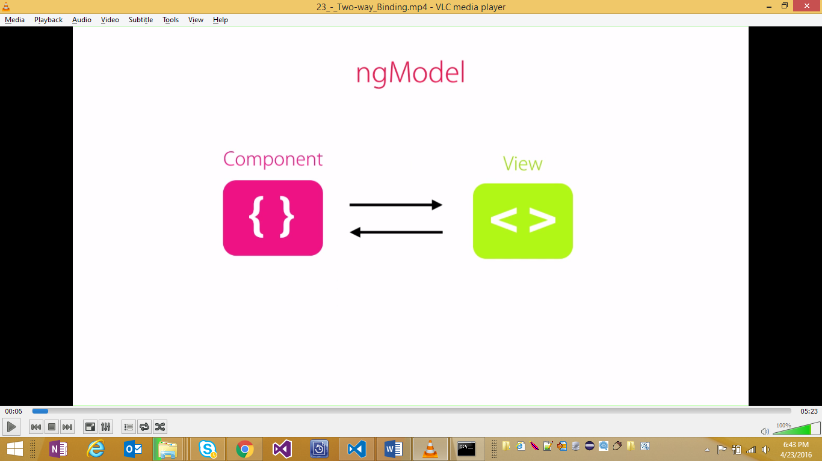

**For creating 2-way binding between dom and component: There are two ways in angular:**

* **Using [(ngModel)]**
* **Using bindon-ngModel**

**Both are same. And can be used**

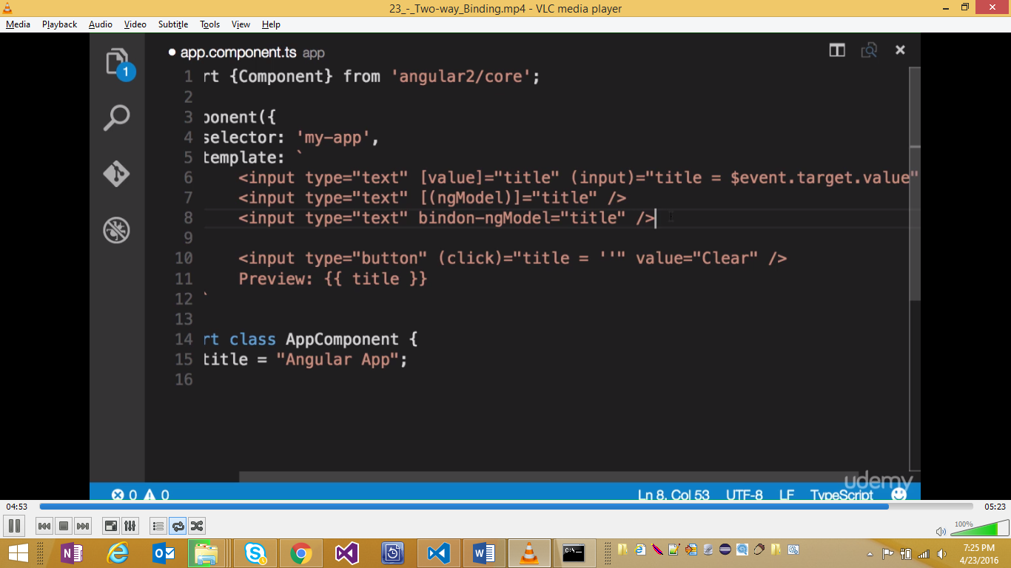

**At core of Angular, there is no 2-way. It something that gotten from flux architecture that data flows in one direction. Thisd allows app[s to be more predctible.**

**2-way binding issyntactical sugar on event and property binding**

**Exercise: Develpp a favorite star icon:**

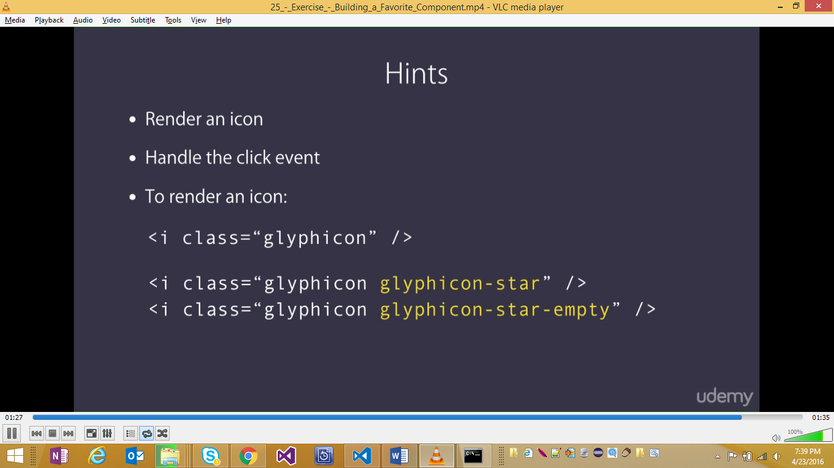

**Building Reusabale Components:**

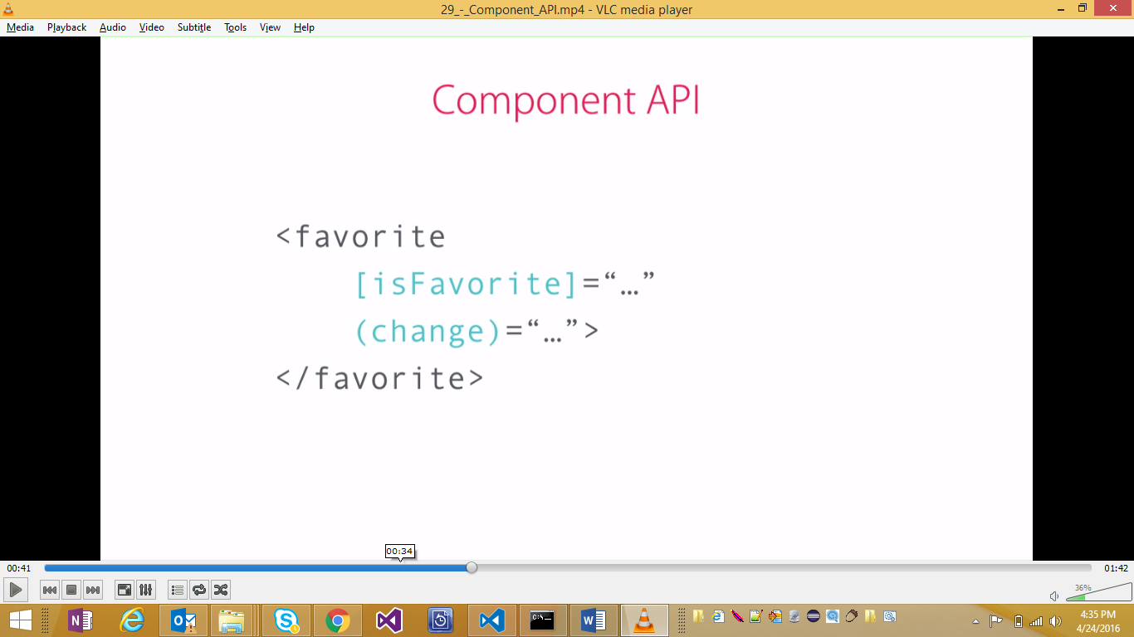

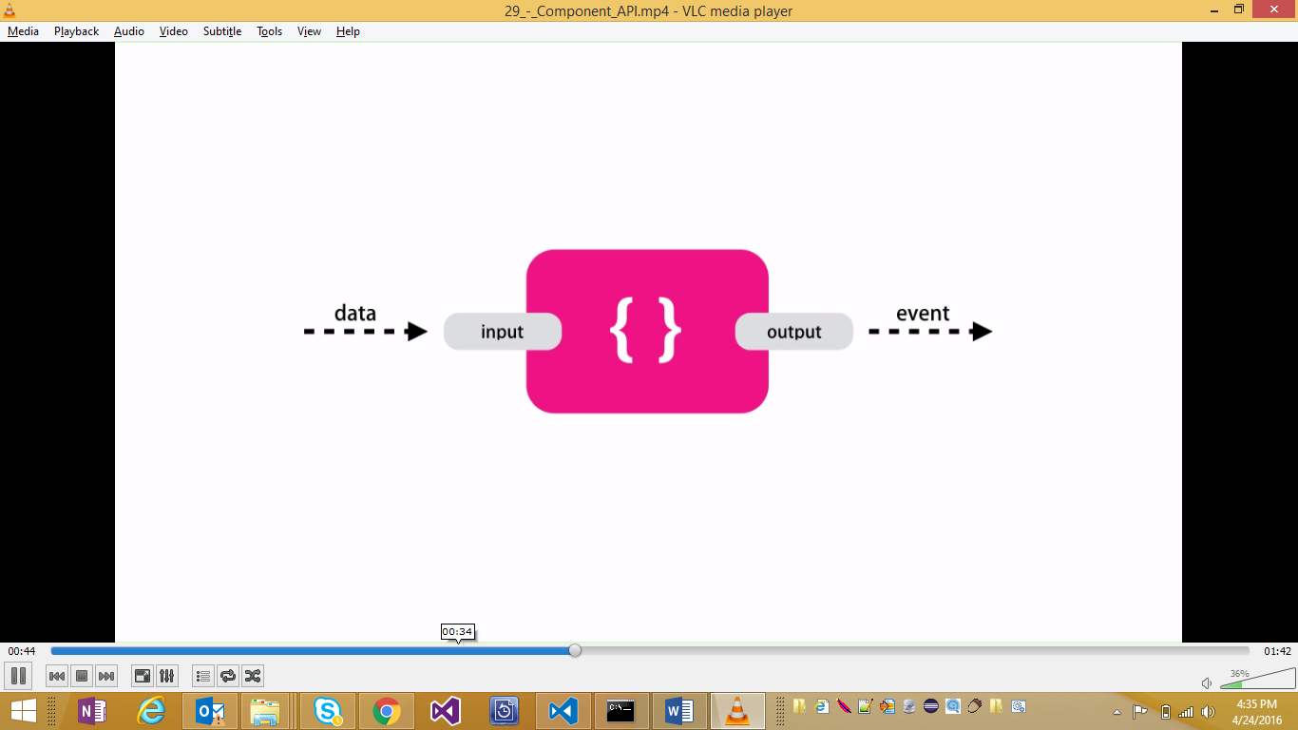

**Example:**

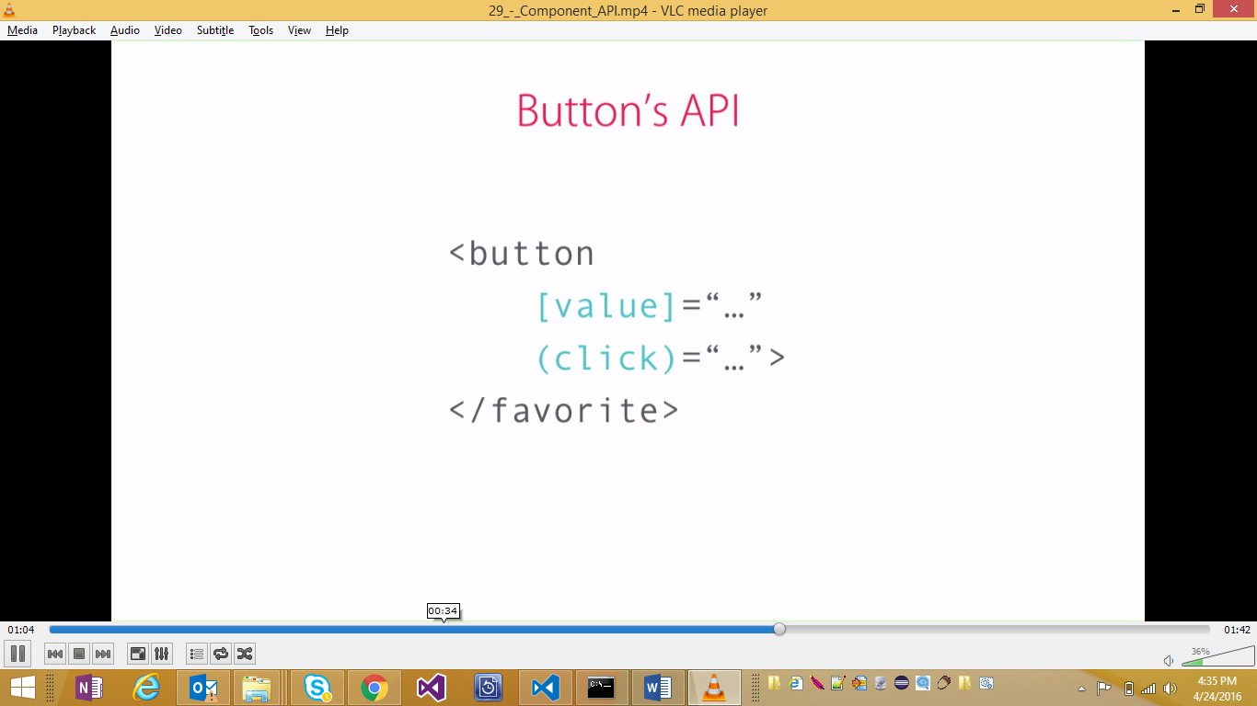

So some of the properties have to be exposed as input properties that can be set from outside and methods have to be exposed as events

There are two ways of exposing a property as input

1. Input Decorator: @Input() isFavorite = false;
2. Compnent Metadata 🡪 Input Array: inputs: [“isFavorite”]

**Advantage of Second approach:** might be better as all the input properties appear in a single place

**Disadvantage of Second Approach:** name of property should match with whats there in the array. If there is any change in the name of property due to refactoring, it will stop working unless the array is updated again.

**Magic String**: in the second approach the name of the property should mathc with the array. So inherent mapping is expected.

**Output Properties:**

**Example 2**: every time user clicks on favorites component, a custom event should be raised so that subscber can take action and may be save to database or submit to DB

Similar to input, output can be defined using one of the two approaches:

1. @output Decorator
2. Output parameter in the Component decorator

**TEMPLATES:**

* If template gets large, it’s a better practice to do it to move to another file and map using templateURL in the annotation
* WE can use either template or templateUrl but not both
* TemplateUrl will cause an extra http request to download the template. But that happens only the first time
* Its more efficient to write inline if it is small

**Styles:**

* Similar to templateURL, styleURL can be used and all the styles can be externalized
* These styles will be scoped and hence will not leak to out html
* This is handled by angular by using an attribute _ngContent-vwg2 – this is generated randomly by angular and corresponding style is created

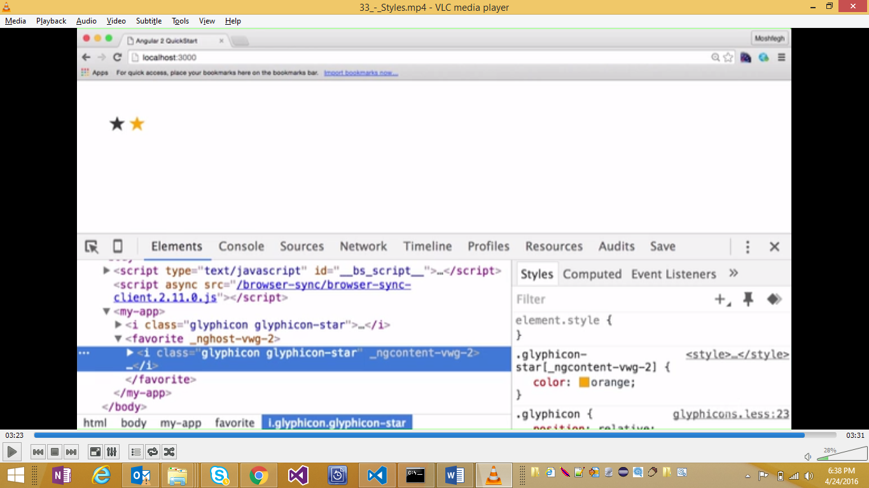

Exercise: Like Component: 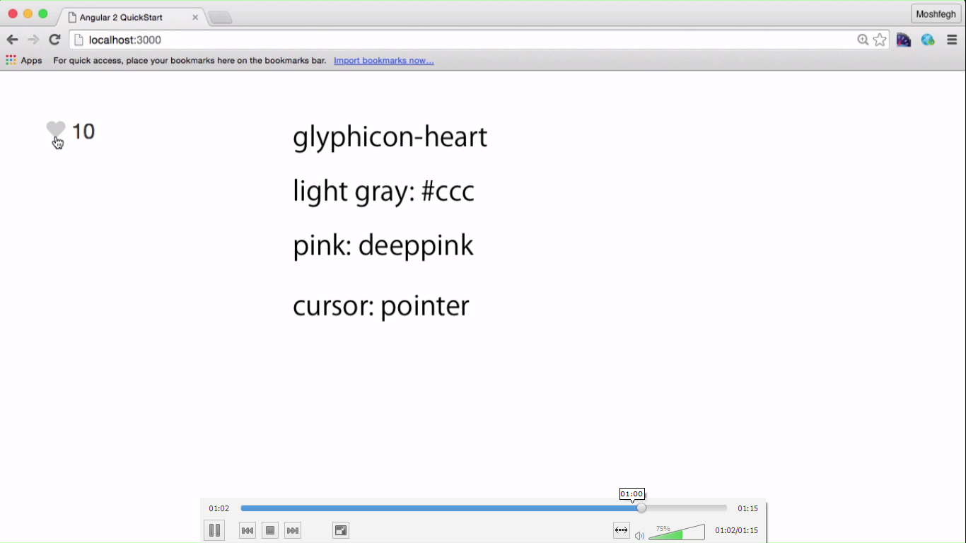

Exercise: Voting Component:

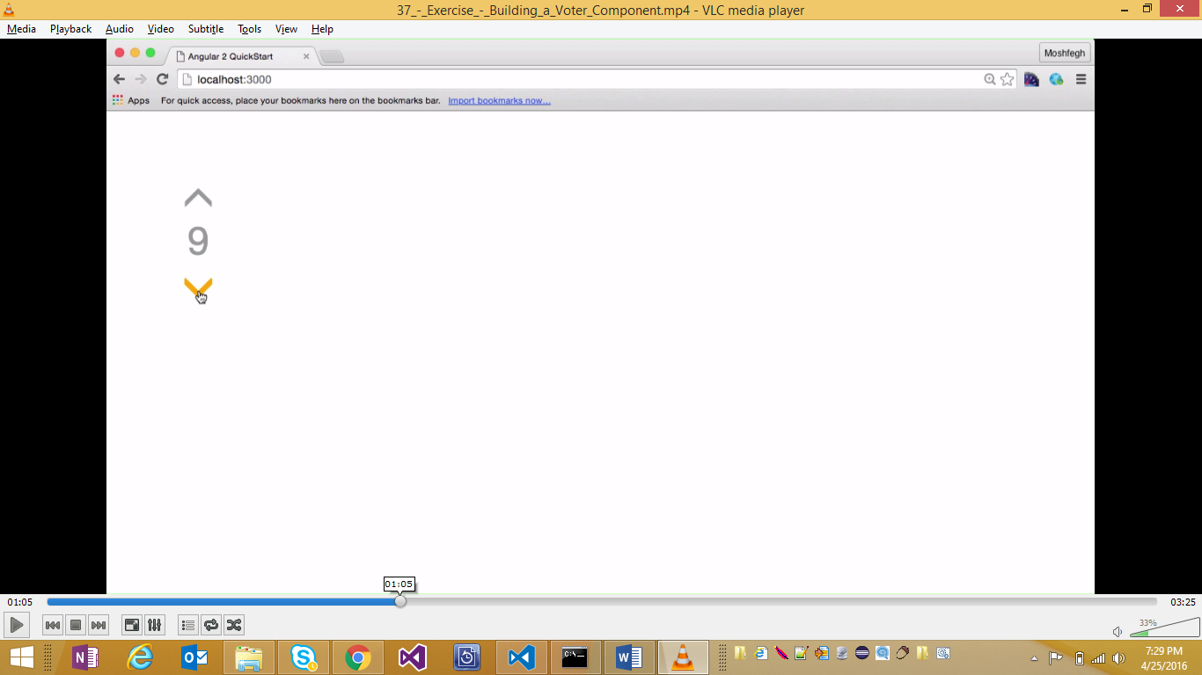

Hints: Try to break down the problem in simpler parts

